**Appendix S1. Picture complexity effects on eye-movements**

In the RT mixed-effects analysis, we controlled for picture complexity by including the variable Target, which refers to the target referent being singular (one alien depicted; 3SG in the audio) or plural (two aliens depicted; 3PL in the audio). This was necessary because pictures that are more complex have been found to attract more looks than less complex pictures (e.g., Lukyanenko & Fisher, 2016; Schlenter, 2019).

The model outcomes revealed effects of picture complexity. The overall prediction effect in our study was delayed when target number was singular, and occurred earlier when it was plural. The pictures displaying a plural agent attracted more looks than the less complex pictures with a singular agent, such that in different-number trials, recognition was sped up in plural target trials relative to singular target trials (Figure S1.1 illustrates this effect). Any researcher planning to develop a visual-world paradigm study should be aware of potential influences of picture complexity on eye-movements and should control for them by adopting a counterbalanced study design (Godfroid, 2020).

**Figure S1.1**

*Proportion of fixations towards the target picture over time as a function of the interaction between Trial condition and Target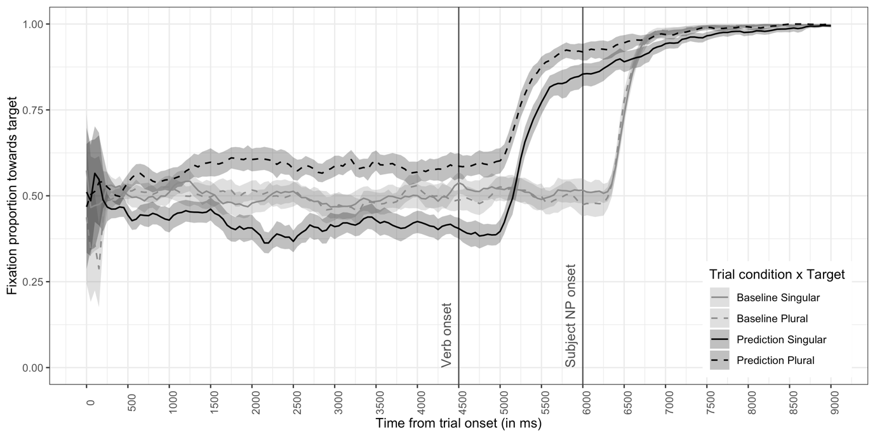*

*Note*. Error bands represent 95% confidence intervals.

***References***

Godfroid, A. (2020). *Eye tracking in second language acquisition and bilingualism: A research synthesis and methodological guide*. Routledge. <https://www.routledge.com/Eye-Tracking-in-Second-Language-Acquisition-and-Bilingualism-A-Research/Godfroid/p/book/9781138024670>

Lukyanenko, C., & Fisher, C. (2016). Where are the cookies? Two- and three-year-olds use number-marked verbs to anticipate upcoming nouns. *Cognition*, *146*, 349–370. <https://doi.org/10.1016/j.cognition.2015.10.012>

Schlenter, J. (2019). *Predictive language processing in late bilinguals: Evidence from visual-world eye-tracking* [Doctoral dissertation, University of Potsdam]. Publication Server of the University of Potsdam. <https://doi.org/10.25932/publishup-43249>